To create a “@hughes.net” Email, please follow the following steps.

- Open web browser and go to website - http://home.myhughesnet.com/

- Select Email:

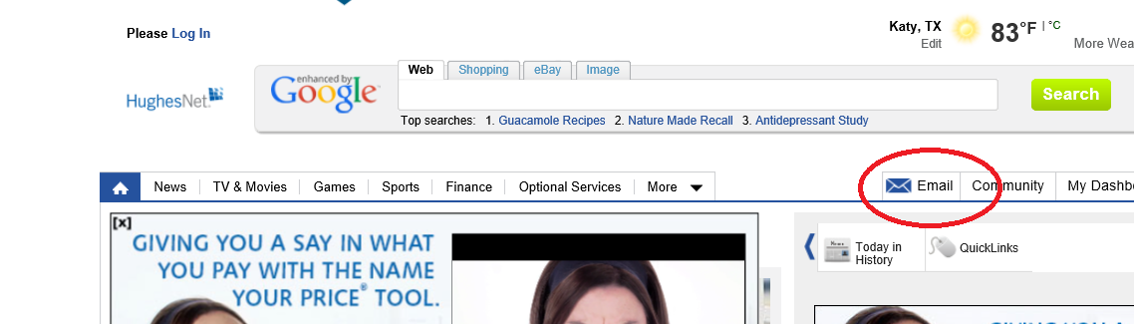

- Select Register
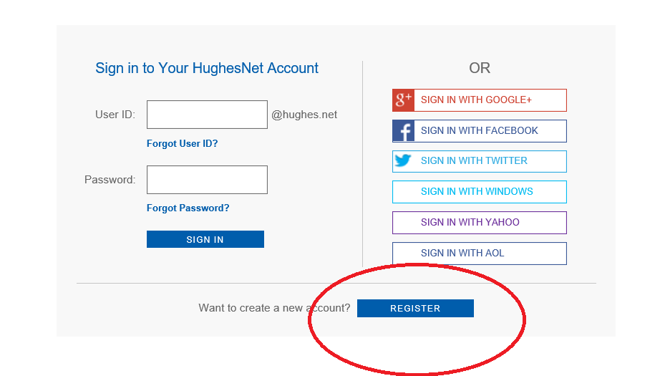

The next step is to enter your SAN, long with our Company phone number: 7134640101

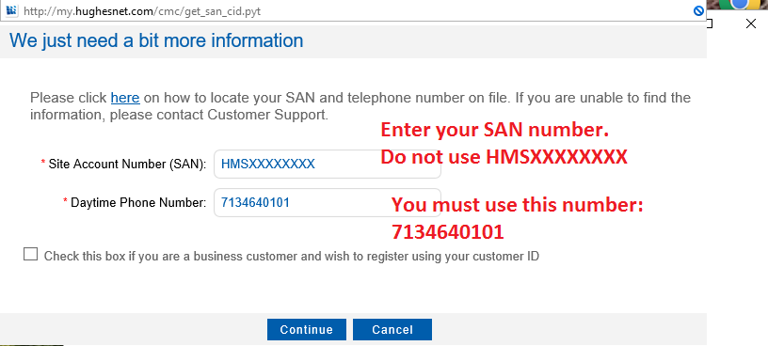
- Then you will be directly to the page to setup your new @hughes.net email account. Fill out the information before and you will be done.
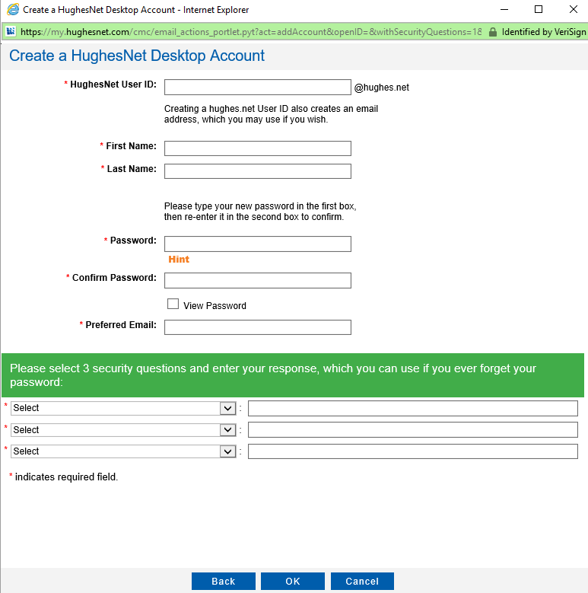

- Once all the information is filled and you select ok, you will receive this message:
