Start by opening up a web browser and type in 192.168.0.1 then follow the prompts. Make sure to place the SBC File on your desktop to easily find file later when needed. 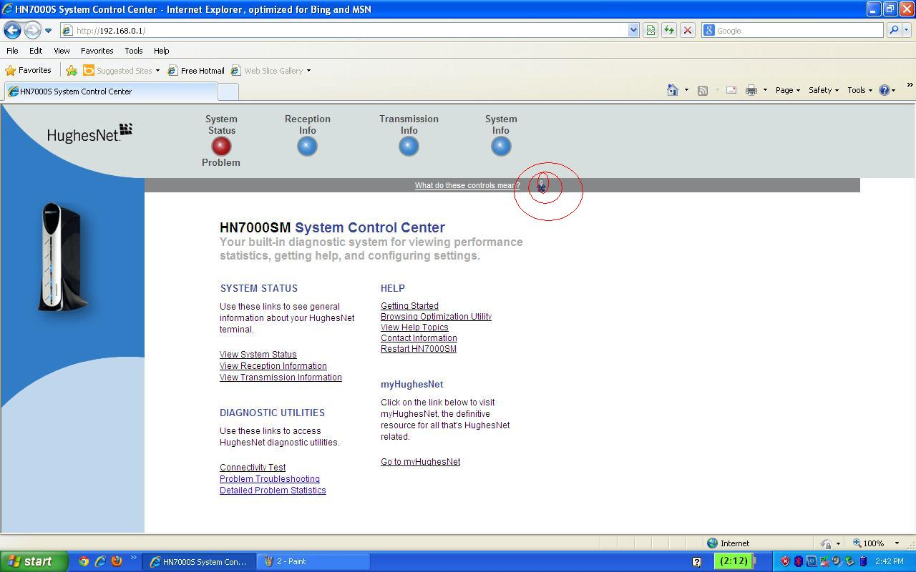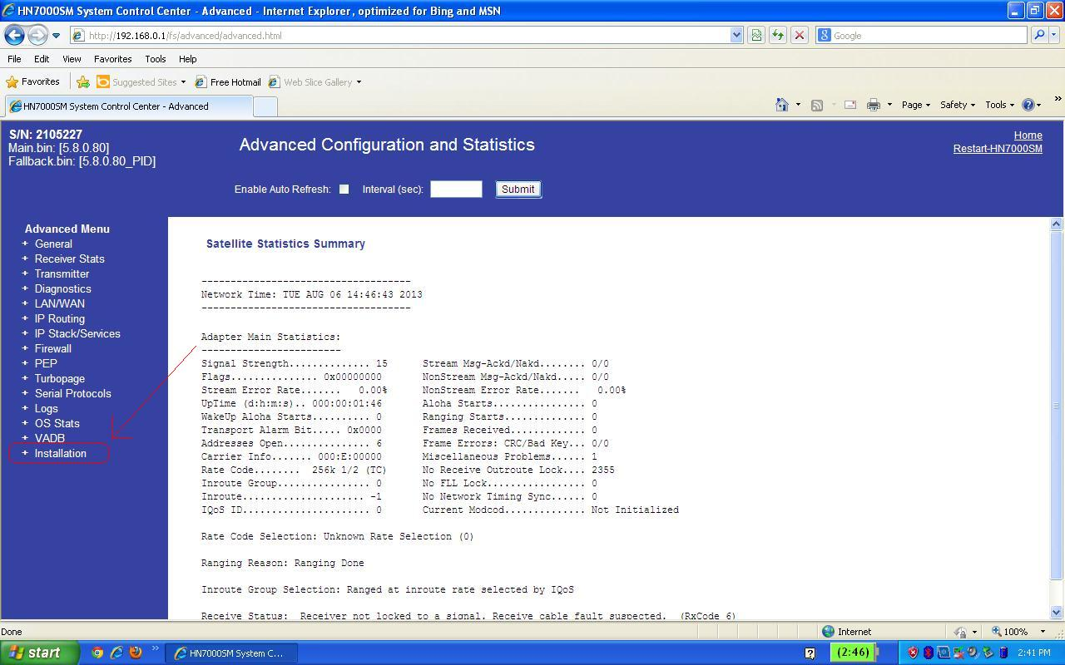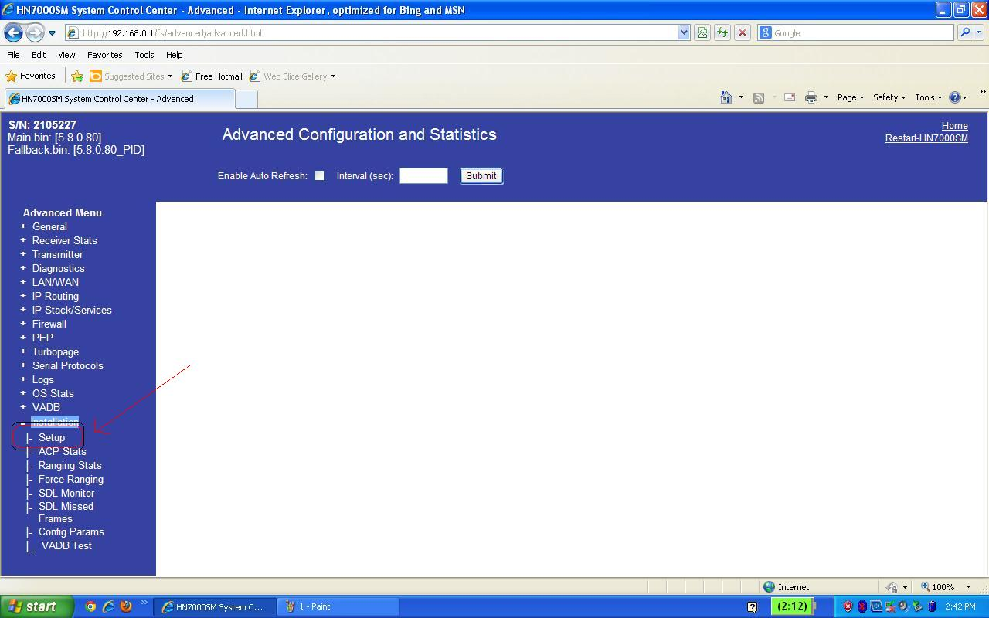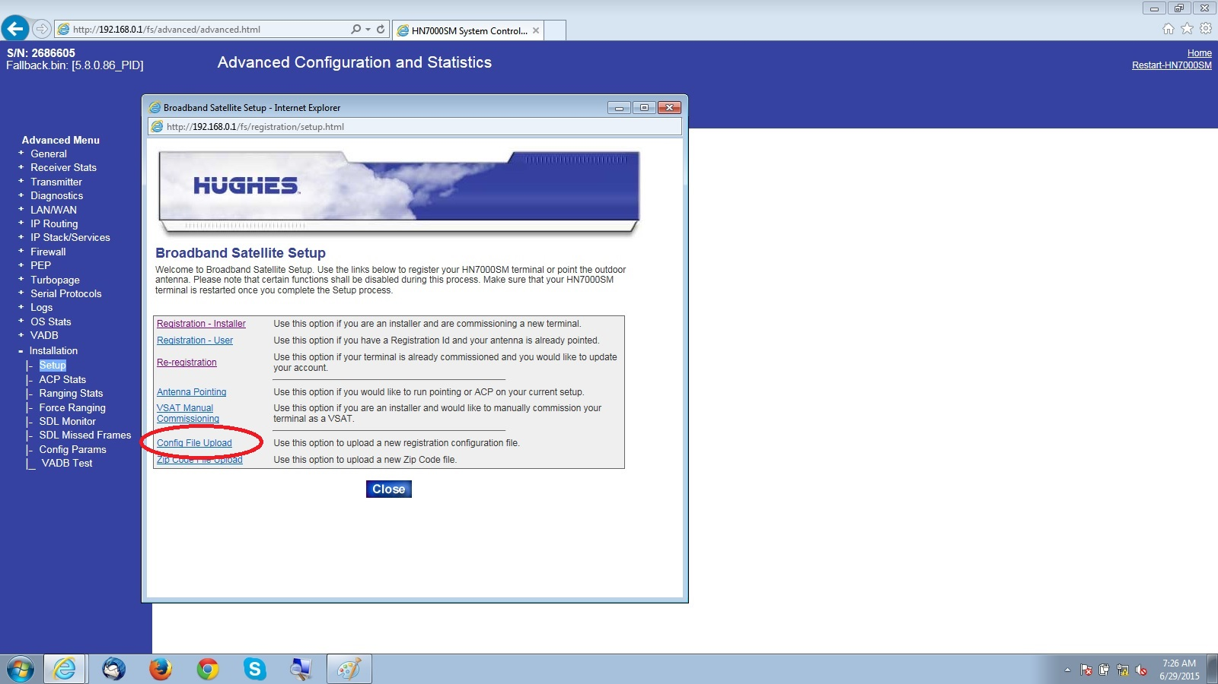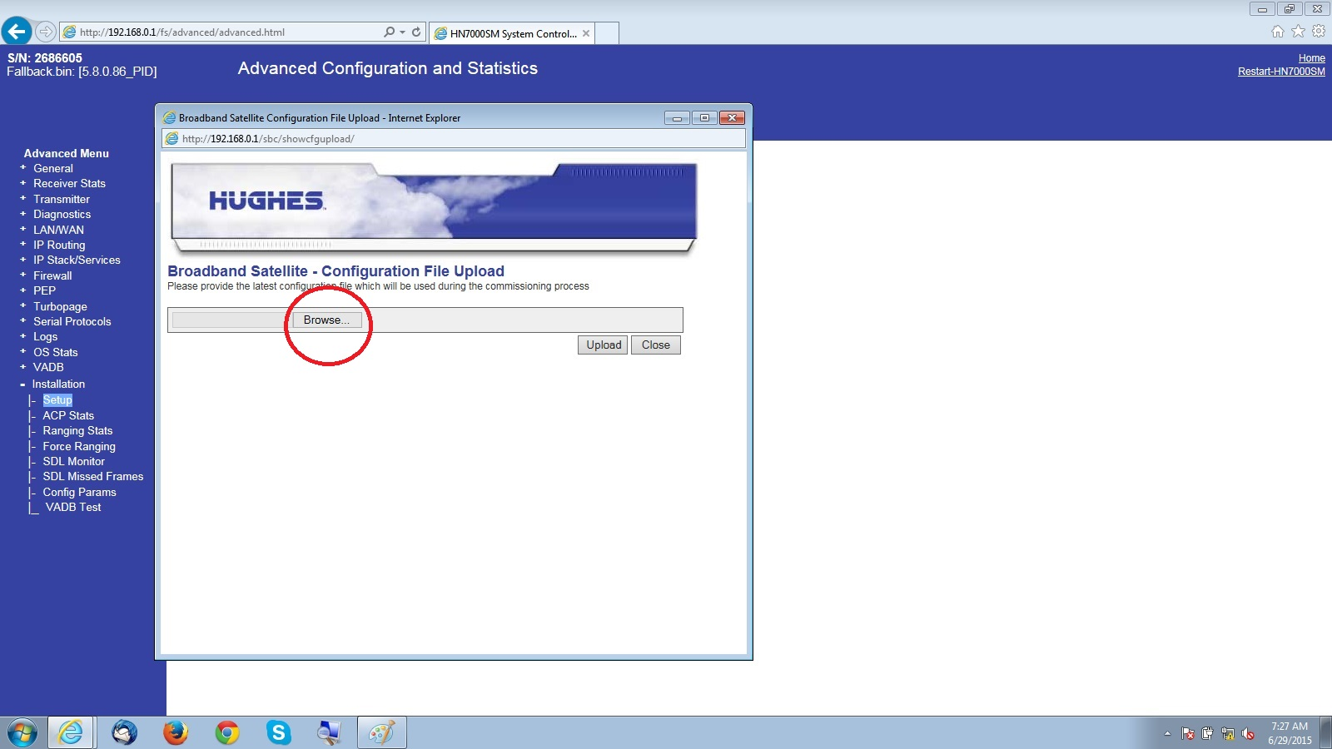
When you select browse, locate the SBC file on your Desktop. Once selected, it will look like the follow page
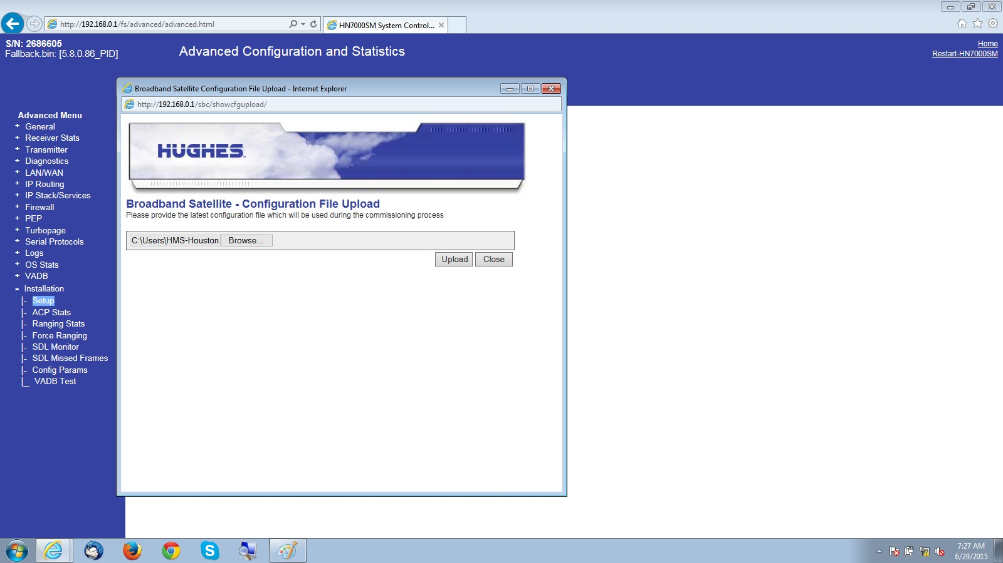
Once file is selected press upload and you should then receive a message like the following page. Then close window.


